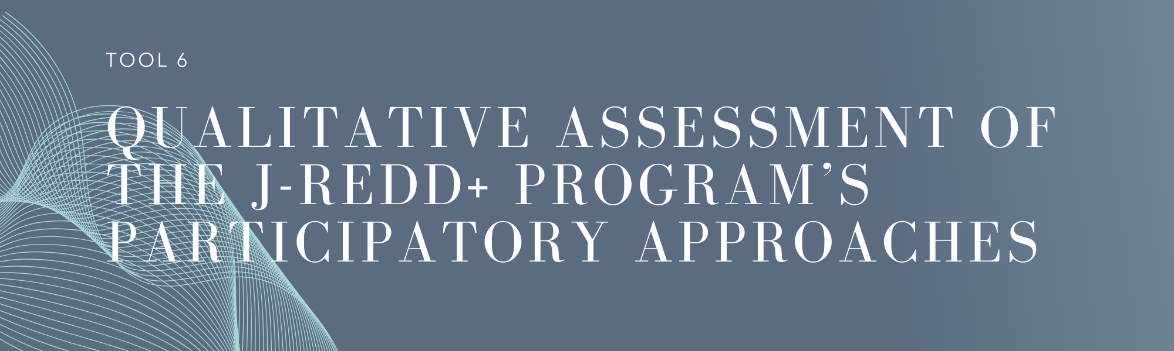

Key Considerations

UNFCCC safeguard ‘D’ refers to the full and effective participation of relevant stakeholders, in particular indigenous peoples and local communities. In addition, UNFCCC Decision 1/CP.16, paragraph 72 requests *developing country Parties, when developing and implementing their national strategies or action plans, to …ensure the full and effective participation of relevant stakeholders, inter alia indigenous peoples and local communities.*

Integrating the voices of communities and individuals into project and programme design and implementation is an essential component of internationally recognised safeguard policies, norms and practices. By engaging early and often with stakeholders, J-REDD+ programs can develop interactive and constructive processes to ensure that people are well-informed, their ideas are advanced, and their concerns are heard and addressed.

For purposes of demonstrating conformance with these UNFCCC requirements, Jurisdictional REDD+ (J-REDD+) programs are expected to put in place tools and processes in alignment with international best practices. International best practices recognize a number of tools[1][2][3]:

* **Stakeholder identification and analysis:** can be used to identify who should be engaged in relation to the J- REDD+ program, and map their priority issues, rights, needs and desires. Particular attention needs to be given to the inclusion of indigenous peoples and other forest-dependent communities, women and other marginalized groups. Stakeholder groups should be supported to self-select representatives where appropriate.
* **Stakeholder engagement plan:** determines the principles and approaches that will be used to ensure the meaningful participation of stakeholders, noting consultations with indigenous peoples must be carried out through their own existing processes, organizations and institutions. The stakeholder engagement plan may encompass the set-up of representation bodies or platforms, such as multi-stakeholder platforms (MSPs)[4], which can serve as participatory structures and mechanisms to facilitate the full and effective participation of stakeholders.
* **Information disclosure:** Disclosure is a formal-sounding term for making information accessible to interested and affected parties. Communicating such information in a manner that is understandable to stakeholders is an important first (and ongoing) step in the process of stakeholder engagement. All other activities, from consultation and informed participation to negotiation and resolution of grievances, will be more constructive if stakeholders, including affected communities, have accurate and timely information about the J-REDD+ program, its impacts, and any other aspects that may have an effect on them.
* **Access to grievance redress mechanisms (GRMs):** GRMs act as recourse for situations in which, despite proactive stakeholder engagement, some stakeholders have a concern about a project or program’s potential impacts on them. Tool 5 examines the quality of available GRMs.

This tool is therefore intended to help J-REDD+ programs better understand:

* The level of alignment of their participatory approaches with international best practices;
* Identify any gaps, weaknesses and/or possible inconsistencies in these arrangements, and identify recommendations to address these.

How to use this tool?

|  |
| --- |
| This tool is divided into two sections:   * **Section A:** presents a questionnaire, which guides users through the technical qualitative assessment of their participatory approaches. * **Section B**: presents a report template, that is to be completed based on the results from Section ‘A’, and will inform the development of the J-REDD+ roadmap (Tool 8). |

Section A - Questionnaire

The questionnaire is structured in different characteristics, which correlate with international best practices.

To complete this questionnaire users should consider the scope of each column as follows:

1. Questions: presents guiding questions for the users. Note that use of the term ‘equivalent’ refers to a sub-national ‘reporting system’.
2. Scoring: the following scoring guide should be applied by users:
   1. **Yes:** The participatory approach incorporates this aspect in conformance with relevant guidance and/or best practices.
   2. **Partially:** The participatory approach partially incorporates this aspect in conformance with relevant guidance and/or best practices. There are some gaps that need to be addressed.
   3.  **No**: The participatory approach does not incorporate this aspect in conformance with relevant guidance and/or best practices, and there are notable gaps that need to be addressed to ensure full conformance.
3. Findings: an opportunity for users to offer information and/or clarifications in relation to their scoring.
4. Means of verification: users should identify any documentation used to support their scoring, including hyperlinks with additional information.

Questionnaire

|  |  |  |  |
| --- | --- | --- | --- |
| **Stakeholder identification and analysis** | | | |
| Questions | Scoring  (Yes/No/Partially) | Comments | Means of verification |
| 1. Has the jurisdiction conducted a stakeholder mapping and analysis for the J-REDD+ program and its REDD+ actions? |  |  |  |
| 1. Does the stakeholder mapping and analysis cover both government and non-governmental stakeholder groups and their representative institutions (including indigenous peoples)? |  |  |  |
| 1. Does the stakeholder mapping and analysis identify which stakeholder groups will be most adversely affected by the REDD+ actions? |  |  |  |
| **Stakeholder engagement plan** | | | |
| Questions | Scoring  (Yes/No/Partially) | Comments | Means of verification |
| 1. Has the jurisdiction adopted a stakeholder engagement plan? |  |  |  |
| 1. Does the stakeholder engagement plan consider arrangements to ensure consultations with indigenous peoples are carried out us through their own existing processes, organizations and institutions? |  |  |  |
| 1. Does the stakeholder engagement plan consider arrangements to ensure consultations are gender inclusive? |  |  |  |
| 1. Does the stakeholder engagement plan take into consideration the cultural norms, practices and values of the stakeholders? |  |  |  |
| 1. Does the stakeholder engagement plan consider the use of representation bodies or platforms, such as Multi Stakeholder Platforms (MSPs)? If so, are these platforms functional? |  |  |  |
| 1. Are the role and functions of the MSPs or equivalent clearly articulated and documented? [i.e. terms of reference adopted and endorsed] |  |  |  |
| 1. Does the stakeholder engagement plan set out clearly how the engagement process will be conducted and how the outcomes will be used, including the rights and responsibilities of the different stakeholders? |  |  |  |
| 1. Does the stakeholder engagement plan set out to keep records of meetings and engagement activities that acknowledge peoples’ perspectives and detail any agreements and timelines for accomplishing tasks? |  |  |  |
| **Information disclosure** | | | |
| Questions | Scoring  (Yes/No/Partially) | Comments | Means of verification |
| 1. Does the jurisdiction’s stakeholder engagement plan or other tool (e.g. communication plan) set out how to inform stakeholders about the implementation of REDD+ actions and their results? |  |  |  |
| 1. Is information provided understandable and contextualised for different stakeholder capacities and languages (e.g. in a format and language that is readily understandable and tailored to the target stakeholder group)? |  |  |  |
| 1. Is information shared within a reasonable period that allows opportunity for stakeholders to participate in an informed manner? |  |  |  |

Section B: Template Report for the Qualitative Assessment

To complete this template report, users (with the support of a selected expert international organization) should consider the answers provided in ‘Section A’ above. In completing this template, users will need to consider the scope of each column as follows:

* Column 2 (Shortcomings or Gaps Identified): for users to identify and summarize the key shortcomings or gaps (issues of non-conformance) identified in correlation to each of the international best practices, that is, when the scoring identified was ‘Partially’ or ‘No’ in ‘Section A’. There is also an opportunity to identify other/general shortcomings.
* Column 3 (Recommendations): for users to identify actions/recommendations to be taken to address these key shortcomings or gaps.

|  |  |  |
| --- | --- | --- |
| International best practices | Shortcomings/Gaps Identified | Recommendations |
| Stakeholder identification and analysis |  |  |
| Stakeholder engagement plan |  |  |
| Information disclosure |  |  |
| General |  |  |

1. FCPF, UN-REDD, 2012. *Guidelines on Stakeholder Engagement in REDD+ Readiness with a Focus on the Participation of Indigenous Peoples and Other Forest-Dependent Communities.* 2012
2. IFC, Stakeholder engagement, Good Practice Manual
3. GCF, Sustainability Guidance Note: Designing and ensuring meaningful stakeholder engagement on GCF-financed activities
4. For purposes of this tool, MSPs are defined as a purposefully organized structures that bring together a range of stakeholders to participate in dialogue and/or decision-making and/or implementation of actions seeking to address a problem they hold in common or to achieve a goal for their common benefit.