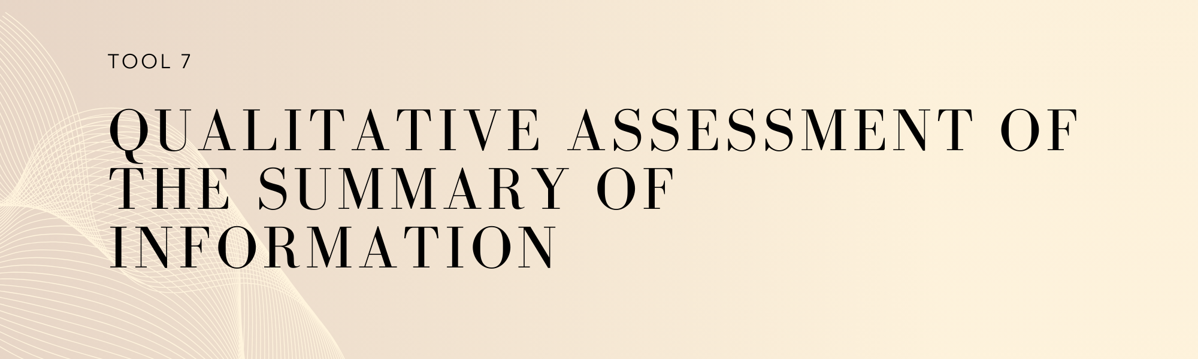

Key Considerations

In order to receive results-based payments, countries must present their most recent summary of information demonstrating how the safeguards have been addressed and respected (usually referred to as the summary of information or SOI)[1], which must be consistent with the guidance from the UNFCCC[2] and international best practices. Sub-national governments are also expected to have submitted to the appropriate national government entity a safeguards report at the respective scale that is consistent with national reporting to the UNFCCC for any year where results-based payments are sought.

The safeguards information system (SIS) and the SOI are directly related. While the SIS is intended to serve as a tool for each country and jurisdiction to gather, compile, and provide information as to how the safeguards are being addressed and respected while implementing REDD+ activities; the SOI is the means by which REDD+ countries and jurisdictions will communicate internationally how they are addressing and respecting the safeguards and, over time, is likely to be a product of the national SIS[3]. In this regard, the SOI is intended to serve as a mechanism to report the actions related to at least three elements:

* How safeguards have been adopted to the country context,
* How safeguards have been addressed, and
* How safeguards have been respected.

The UNFCCC provides some guidance on the content of the SOI[4]. The SOI should include the following elements, where appropriate:

1. Information on national circumstances relevant to addressing and respecting the safeguards;
2. A description of each safeguard in accordance with national circumstances;
3. A description of existing systems and processes relevant to addressing and respecting safeguards, including the information systems referred to in decision 12/CP.17, in accordance with national circumstances;
4. Information on how each of the safeguards has been addressed and respected, in accordance with national circumstances;

The UNFCCC also encourages to provide any other relevant information and to improve the information provided, taking into account the stepwise approach.

The UNFCCC decision also specifies[5] that the SOI should be provided after the beginning of implementation of REDD+ activities with the national communications, or on a voluntary basis including via the Web Platform of the UNFCCC, or any other means agreed by the COP.

In alignment with UNFCCC guidance, the international best practices[6][7], over the content and structure of the SOI consider the following components:

1. **Introduction**: this section can set out the scope of the report, including the applicable safeguards commitments that inform the formulation and dissemination of this report, the specific objectives of this report, and it associated reporting period.
2. **National context and REDD+ overview:** this section can provide a clear overview of the scope, scale and stage of design and implementation of the of the REDD+ actions that are subject to this period of reporting.
3. **Description of each safeguard:** this section can explain how each of the UNFCCC REDD+ safeguards is understood by the country, according to the country’s context and specific circumstances. A large number of countries have developed their description as part of their approach to safeguards. The description of safeguards can be presented as a narrative text with several elements; or a set of principles and criteria defined for each safeguard. This section may be included in the first SOI, and in subsequent SOI if subject to any updates.
4. **Conformance with REDD+ safeguards:** this section can provide information over how the seven safeguards are being addressed and respected throughout the implementation of the REDD+ actions, for each specific results period. Generally, this section would include information about the jurisdictions’ governance arrangements in place to guarantee the application of the safeguards, and what are the associated outcomes (e.g. how the REDD+ safeguards have been respected when implementing REDD+ actions). This section may also identify challenges (if any) in ensuring conformance with the safeguards throughout the implementation of the REDD+ actions, and identify potential measures for improvement.
5. **Stakeholder engagement:** this section can include information related to the stakeholder engagement process for the preparation of this report, and how their inputs were integrated into this report.

This tool is therefore intended to help J-REDD+ programs better understand:

* The level of alignment of their summary of information in correlation with the UNFCCC’s guidance and international best practices.
* Identify any gaps, weaknesses and/or possible inconsistencies in these arrangements, and identify recommendations to address these.

How to use this tool?

|  |
| --- |
| This tool is divided into two sections:   * **Section A:** presents a questionnaire, which guides users through the technical qualitative assessment of the SOI. * **Section B**: presents a report template, that is to be completed based on the results from Section ‘A’, and will inform the development of the J-REDD+ roadmap (Tool 8). |

Section A - Questionnaire

The questionnaire is structured in different categories, which correlate with UNFCCC guidance and international best practices.

To complete this questionnaire users should consider the scope of each column as follows:

1. Questions: presents guiding questions for the users. Note that use of the term ‘equivalent’ refers to a sub-national ‘reporting system’.
2. Scoring: the following scoring guide should be applied by users:
   1. **Yes:** The SOI incorporates this aspect in conformance with relevant guidance and/or best practices.
   2. **Partially:** The SOI partially incorporates this aspect in conformance with relevant guidance and/or best practices. There are some gaps that need to be addressed.
   3.  **No**: The SOI does not incorporate this aspect in conformance with relevant guidance and/or best practices, and there are notable gaps that need to be addressed to ensure full conformance.
3. Findings: an opportunity for users to offer information and/or clarifications in relation to their scoring.
4. Means of verification: users should identify any documentation used to support their scoring, including hyperlinks with additional information.

Management Approach

|  |  |  |  |
| --- | --- | --- | --- |
| **National context and REDD+ overview** | | | |
| Questions | Scoring  (Yes/No/Partially) | Comments | Means of verification |
| 1. Does the SOI provide information on the scope, scale and stage of design and implementation of the of the REDD+ actions that are subject to this period of reporting? |  |  |  |
| 1. Does the SOI provide information on any overarching governance arrangements and processes in place to respond to safeguards requirements for REDD+ (e.g. the SIS)? |  |  |  |
| **Description of each safeguard** | | | |
| Questions | Scoring  (Yes/No/Partially) | Comments | Means of verification |
| 1. Does the SOI include a description of each safeguard in accordance with national circumstances? |  |  |  |
| 1. Does the SOI provide information on the stakeholder engagement process conducted to adopt the description of each safeguard? |  |  |  |
| **Conformance with REDD+ safeguards** | | | |
| Questions | Scoring  (Yes/No/Partially) | Comments | Means of verification |
| 1. Does the SOI identify and describe the overarching legal and institutional arrangements that guarantee conformance with each safeguard and the context of the implementation of the REDD+ actions? |  |  |  |
| 1. Does the SOI provide information of the particular outcomes of the REDD+ actions in correlation to each safeguard? |  |  |  |
| 1. Does the SOI identify challenges (including capacity, financial, and technical needs) in ensuring conformance with the safeguards, and identify potential measures for improvement? |  |  |  |
| **Stakeholder engagement** | | | |
| Questions | Scoring  (Yes/No/Partially) | Comments | Means of verification |
| 1. Does the SOI present information on how the SOI was prepared? |  |  |  |

Section B: Template Report for the Qualitative Assessment

To complete this template report, users (with the support of from a selected expert international organization) should consider the answers provided in ‘Section A’ above. In completing this template, users will need to consider the scope of each column as follows:

* Column 2 (Shortcomings or Gaps Identified): for users to identify and summarize the key shortcomings or gaps (issues of non-conformance) identified in correlation to each of the international best practices, that is, when the scoring identified was ‘Partially’ or ‘No’ in ‘Section A’. There is also an opportunity to identify other/general shortcomings.
* Column 3 (Recommendations): for users to identify actions/recommendations to be taken to address these key shortcomings or gaps. Zoom in on the company's sustainability performance within the reporting period, including progress toward goals and targets.

|  |  |  |
| --- | --- | --- |
| International Best Practices | Shortcomings/Gaps Identified | Recommendations |
| National Context and REDD+ overview |  |  |
| Description of each safeguard |  |  |
| Conformance with safeguards |  |  |
| Stakeholder engagement |  |  |
| General |  |  |

1. UNFCCC Decision 9/CP, Paragraph 4; Decision 2/CP.17, Paragraph 63 and 64; Decision 12/CP.17 paragraph 3 and 4.
2. UNFCCC decision 17/CP.2. , requires the full and effective participation of relevant stakeholders, inter alia indigenous peoples and local communities; when developing and implementing national strategies or action plans, to address, inter alia, the drivers of deforestation and forest degradation, land tenure issues, forest governance issues, gender considerations and the UNFCCC safeguards.
3. Braña Varela, J., Lee, D., Rey Christen, D., and Swan, S. 2014. “REDD+ Safeguards: Practical Considerations for Developing a Summary of Information.” Prepared with support from the Government of Norway’s International Climate and Forest Initiative. Available at www.merid.org/reddsafeguards.
4. UNFCCC Decision 12/CP17
5. FCCC/SBSTA/2013/3/Add.1
6. Braña Varela, J., Lee, D., Rey Christen, D., and Swan, S. 2014. “REDD+ Safeguards: Practical Considerations for Developing a Summary of Information.” Prepared with support from the Government of Norway’s International Climate and Forest Initiative. Available at www.merid.org/reddsafeguards.
7. UN-REDD programme infobrief, Summaries of Information: Initial experiences and Recommendations on International redd+ Safeguards reporting. Available at: <https://www.un-redd.org/sites/default/files/2021-10/InfoBrief__Summaries_of_information_30Sep%20%28735777%29.pdf>